**Python Database Programming Exercise**

This Database exercise Project will help Python developers to learn database programming skills quickly. In this exercise, we will perform database CRUD operations using Python.

**Note**:

This exercise covers the following three popular database servers. You can choose the database server you are familiar with to solve this exercise.

* MySQL
* PostgreSQL
* SQLite

You can use any driver (DB module) as per your wish, for example, there are more than 5 libraries are available to communicate with MySQL. In this exercise, I am using the following libraries.

* MySQL: mysql connector python
* PostgreSQL: psycopg2
* SQLite: sqlite3

**This Python database programming exercise includes**: –

Now it has 5 exercise questions, which simulate the real-time queries, and each question contains a specific skill you need to learn. When you complete the exercise, you get more familiar with database operations in Python.

### Exercise/mini Project: Hospital Information System

In this exercise, We are implementing the Hospital Information System. In this exercise, I have created two tables, **Hospital** and **Doctor**. You need to create those two tables on your database server before starting the exercise.

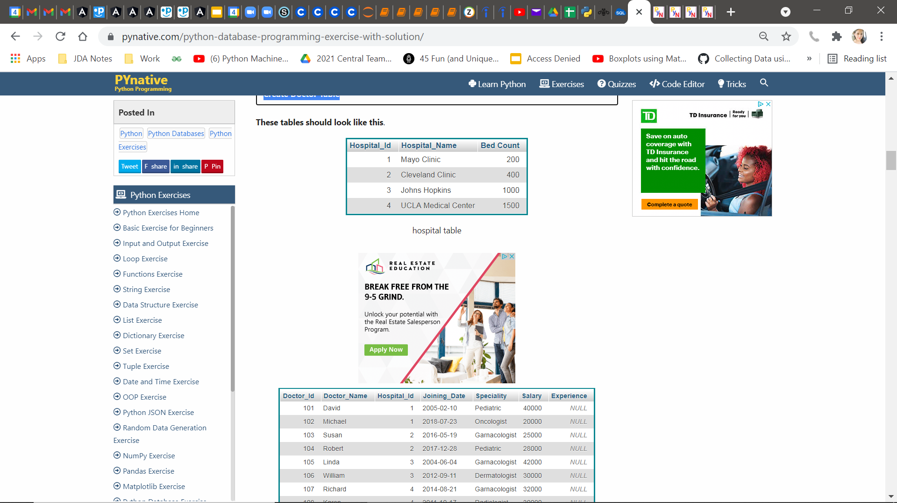

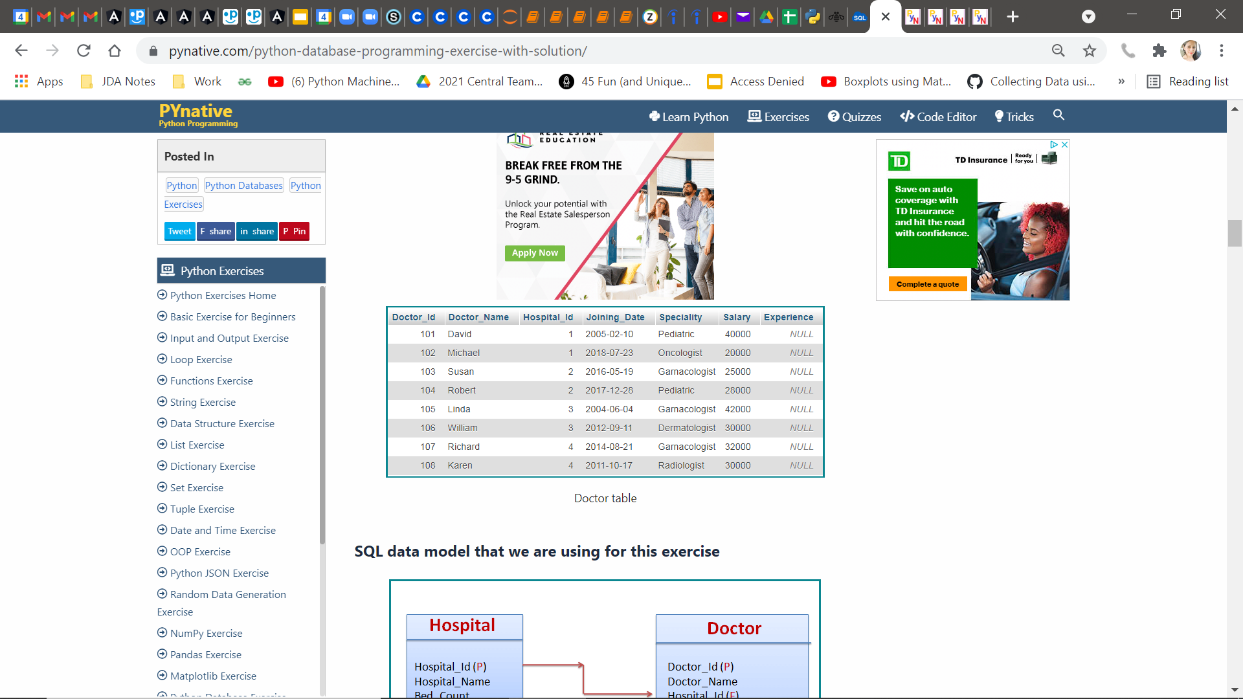

### Exercise 1: Connect to your database server and print its version

### Exercise 2: Fetch Hospital and Doctor Information using hospital Id and doctor Id

### Exercise 3: Get the list Of doctors as per the given specialty and salary

### Exercise 4: Get a list of doctors from a given hospital

### Exercise 5: Update doctor experience in years